OBSTACLE AVOIDANCE ROBOT
Dr. B. Naveen Kumar, R. Sanjana, N. Srikanth, S. Chandu, N. Saikumar, T.Rakesh
Associate Professor, Department of Electronics and Communication Engineering,Balaji Institute of Technology and Science, Narsampet, Warangal, Telangana, India
Students, Department of Electronics and Communication Engineering, Balaji Institute of Technology and Science, Narsampet, Warangal, Telangana, India.
Abstract
An obstacle avoiding robot is an intelligent embedded system designed to detect and avoid obstacles in its path automatically. This project is implemented using an Arduino microcontroller and an ultrasonic sensor to measure the distance between the robot and nearby objects. When an obstacle is detected within a predefined range, the robot changes its direction to avoid collision.The system uses DC motors controlled through a motor driver to move the robot in different directions. The ultrasonic sensor continuously sends and receives sound waves to identify obstacles in real time. Based on the sensor data, the Arduino processes the information and makes decisions to stop, turn left, or turn right.This project demonstrates the basic concepts of robotics, automation, and embedded systems. It is useful for understanding real-time applications such as autonomous vehicles, industrial automation, and smart robotic systems. The obstacle avoiding robot is simple, cost-effective, and suitable for academic miniprojects and learning purposes.
- Introduction
An Obstacle Avoidance Robot with Voice and BluetoothControl is an intelligent mobile robot designed to move automatically while detecting and avoiding obstacles in its path. The system is built using an Arduino Uno microcontroller, an ultrasonic sensor for obstacle detection, a motor driver, DC motors, and a Bluetooth module. It can operate in three modes: obstacle avoidance mode, voice control mode, and Bluetooth control mode.
In obstacle avoidance mode, the ultrasonic sensor continuously measures the distance between the robot and nearby objects. When an obstacle is detected, the Arduino processes the sensor data and directs the robot to change its path, preventing collisions. In voice control mode, the robot receives voice commands from a smartphone application and performs actions such as moving forward, backward, left, or right. In Bluetooth control mode, users can manually control the robot wirelessly through a Bluetooth-enabled mobile device.
The Obstacle Avoidance Robot with Voice and Bluetooth Control is a multifunctional robotic system that combines automation and wireless control technologies. The robot is capable of navigating its surroundings independently by detecting obstacles and avoiding collisions using an ultrasonic sensor. In addition, it can be controlled manually through voice commands and Bluetooth communication from a smartphone.
The core component of the system is the Arduino Uno microcontroller, which acts as the brain of the robot. It receives input from sensors and user commands, processes the information, and controls the movement of the motors accordingly. The HC-SR04ultrasonic sensor is used to measure the distance between the robot and nearby objects. When an obstacle is detected within a predefined range, the Arduino automatically changes the robot's direction to avoid collision.
For wireless control, the robot uses an HC-05 Bluetooth module that establishes communication between the robot and a smartphone. Through a Bluetooth application, users can send commands such as Forward, Backward, Left, Right, and Stop. Voice commands are also converted into text commands by a smartphone application and transmitted to the robot via Bluetooth, enabling hands-free operation.
This project combines embedded systems, wireless communication, and automation technologies to create a versatile robotic platform. It has applications in industrial automation, surveillance, military assistance, and smart transportation systems. The project also helps students understand the practical implementation of sensors, microcontrollers, wireless communication, and robotic control systems.
2. Literature Review
Sahil S. Nimsatkar et al. developed a robotic vehicle using an Arduino Uno, ultrasonic sensor, Bluetooth module, and motor driver. The system can avoid obstacles automatically while also responding to voice commands received through a Bluetooth-connected Android application. The study demonstrated improved flexibility by combining autonomous and manual control modes[1].Akanksha Dash et al. proposed an intelligent robotic vehicle based on the ATmega328 microcontroller. The robot detects obstacles using an HC-SR04 ultrasonic sensor and changes direction automatically. Bluetooth and voice control functionalities allow users to remotely control the robot through a smartphone application. The authors highlighted the effectiveness of combining obstacle detection with wireless control[2].M. V. Sreenivas Rao designed a voice-controlled robot that receives commands through a Bluetooth HC-05 module. The Arduino Uno processes the commands and controls motor movement. An ultrasonic sensor continuously monitors the surroundings and prevents collisions by detecting obstacles. The study showed that voice control improves accessibility and ease of operation [3]. Vedant Gaikwad and colleagues developed a robotic vehicle that responds to user voice commands through an Android application. The Bluetooth module serves as the communication link, while ultrasonic sensors enable autonomous obstacle detection andavoidance. Their work emphasized the importance of safety through automatic braking and route adjustment when obstacles are encountered [4].

Kausthubh Y. V. Devi et al. introduced a Smart Rover integrating Bluetooth communication, voice control, and obstacle avoidance. The system demonstrated reliable navigation in dynamic environments and showed the potential for future IoT integration to improve remote monitoring and control capabilities [5].Muskan Yadav et al. reviewed various obstacle avoidance and voice-controlled robotic systems. The authors concluded that integrating voice commands, Bluetooth communication, and autonomous obstacle detection creates a cost-effective and user-friendly robotic platform suitable for transportation assistance, security applications, and hazardous environments [6].IoT-based obstacle avoidance robot using Arduino and ultrasonic sensors. Their work integrated wireless communication capabilities with obstacle detection, allowing remote monitoring and control. The study highlighted the importance of combining robotics with IoT technologies for smart automation applications [7].Developed an obstacle-avoiding robotic vehicle using an Arduino microcontroller and ultrasonic sensors. The system detects obstacles in front and on both sides of the robot and automatically selects a collision-free path. The authors reported that ultrasonic sensing combined with Arduino control provides a simple and cost-effective solution for autonomous navigation [8].Designed an obstacle avoidance robot using an Arduino Uno and an ultrasonic sensor. The robot continuously measures the distance between itself and nearby objects. When an obstacle is detected within a predefined range, the robot changes its direction to prevent collisions. The research demonstrated reliable obstacle detection and simple autonomous movement [9]. Developed an obstacle-avoiding robot using an Arduino Uno and HC-SR04 ultrasonic sensor. The robot successfully navigated unknown environments without collisions. The authors concluded that the use of inexpensive and readily available components makes the system suitable for educational and research purposes [10].
- Methodology
The obstacle avoidance robot with voice and Bluetooth control features consists of several interconnected components that work together to enable both automatic and manual operation. The system is powered by a battery supply with a voltage regulator that provides the required power to all modules. At the core of the system is a microcontroller, typically an Arduino, which acts as the brain of the robot by processing inputs and generating appropriate control signals. The ultrasonic sensor is used for obstacle detection by measuring the distance between the robot and nearby objects, allowing the robot to automatically avoid collisions. For manual control, a Bluetooth module such as HC-05 or HC-06 is used to establish wireless communication between the robot and a mobile application, through which the user can send movement commands like forward, backward, left, and right. In addition to this, a voice recognition module or a smartphone-based voice control application enables the robot to respond to spoken commands. All input signals from the sensor, Bluetooth module, and voice system are processed by the microcontroller, which then sends control signals to the motor driver module, typically L298N.

3.1 Block Diagram
The proposed system is designed to combine autonomous obstacle avoidance with manual control using voice and Bluetooth.
The methodology of the Obstacle Avoidance Robot with Voice & Bluetooth Control is based on integrating autonomous navigation with user-controlled operation. The system is built around a microcontroller such as the Arduino Uno, which acts as the brain of the robot. All input and output components—including sensors, communication modules, and motors—are connected to this controller to ensure coordinated functioning.
The hardware setup includes an ultrasonic sensor for obstacle detection, a motor driver (L293D) to control the movement of DC motors, and a Bluetooth communication module like the HC-05 Bluetooth Module. The ultrasonic sensor continuously measures the distance between the robot and nearby objects by sending and receiving signals. When an obstacle is detected within a predefined distance, the microcontroller processes this information and commands the motors to stop or change direction, thereby avoiding collisions.
The system is programmed using embedded C in the Arduino IDE, where the algorithm continuously monitors sensor data and incoming commands. It prioritizes obstacle avoidance to ensure safety while also allowing user control when required. After integrating all components, the robot is tested and calibrated in different environments to improve accuracy, responsiveness, and reliability. Finally, the robot operates efficiently in both autonomous and manual modes, making it suitable for various practical applications.
In addition to autonomous operation, the robot supports manual control through Bluetooth and voice commands. A smartphone is used as the control interface, where commands are sent via a Bluetooth connection. The Bluetooth module receives these commands and forwards them to the microcontroller, which interprets them and drives the motors accordingly. For voice control, a mobile application converts spoken instructions into text-based commands, which are then transmitted through Bluetooth and executed by the robot.
The working principle of an obstacle avoidance robot with voice and Bluetooth control features is based on the integration of sensing, processing, and control systems to enable both autonomous and user-directed operation. The robot is powered by a battery, and all components are managed by a microcontroller, typically an Arduino, which serves as the central processing unit. In automatic mode, the ultrasonic sensor continuously emits ultrasonic waves and measures the time taken for the echo to return after hitting an obstacle, thereby calculating the distance. If an object is detected within a predefined threshold, the microcontroller processes this input and sends signals to the motor driver to stop, reverse, or change the direction of the robot to avoid collision. In manual mode, the robot can be controlled either through a Bluetooth module or voice commands. The Bluetooth module establishes a wireless connection with a smartphone, allowing the user to send directional commands through a mobile application. Similarly, voice commands are captured either through a dedicated voice recognition module or a smartphone app, converted into digital signals, and transmitted to the microcontroller. Based on these inputs, the microcontroller generates appropriate control signals to the motor driver, which then drives the DC motors to move the robot in the desired direction. By combining autonomous obstacle detection with Bluetooth and voice-based control, the system provides flexible and efficient navigation in different environments.
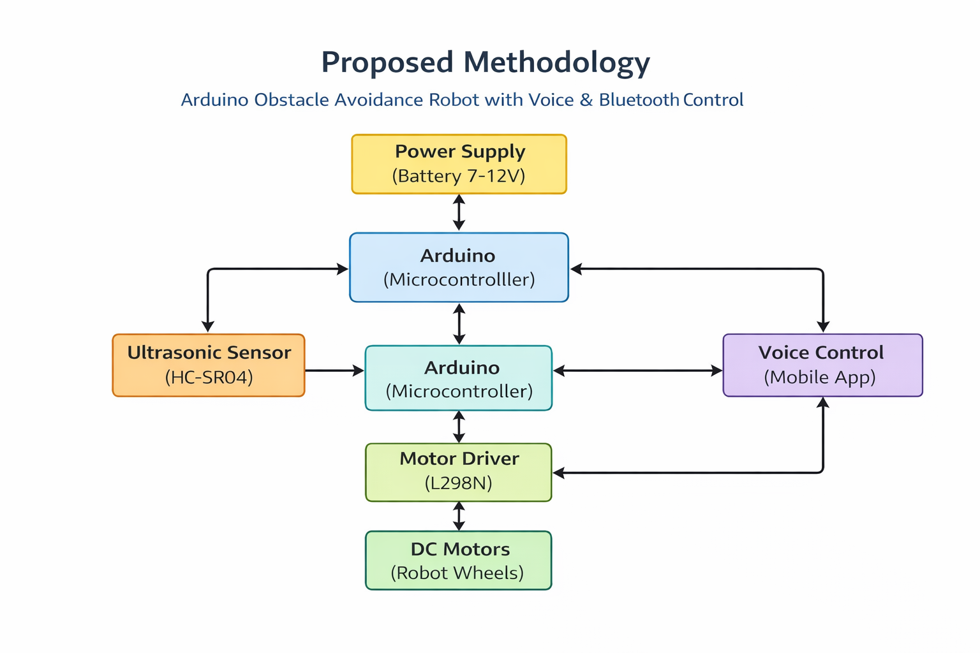

- Results and Analysis

The Arduino-based Obstacle Avoidance Robot was successfully designed and implemented using an Arduino microcontroller, ultrasonic sensor, motor driver, and DC motors. The robot was able to detect obstacles placed in its path and automatically change its direction to avoid collisions. The ultrasonic sensor continuously measured the distance between the robot and nearby objects. When an obstacle was detected within the predefined threshold distance (typically 15–20 cm), the Arduino processed the sensor data and instructed the motors to stop, reverse slightly, and turn toward a clear path.
During testing, the robot demonstrated reliable obstacle detection and avoidance in indoor environments. It was capable of navigating around stationary objects such as walls, boxes, chairs, and other obstacles without human intervention. The response time of the robot was fast enough to prevent collisions under normal operating speeds. The robot achieved smooth movement on flat surfaces and maintained stable operation throughout multiple test runs.
The system successfully met its primary objective of autonomous navigation and obstacle avoidance. The integration of sensors, control algorithms, and motor control circuits functioned effectively, proving the feasibility of using Arduino for low-cost robotic applicationsThe performance analysis of the obstacle avoidance robot indicates that the ultrasonic sensor played a crucial role in detecting obstacles accurately. The sensor provided distance measurements with reasonable precision, allowing the Arduino to make timely navigation decisions. The robot's ability to avoid obstacles depended on factors such as sensor range, motor speed, environmental conditions, and the efficiency of the programmed algorithm. Experimental observations showed that the robot performed best on smooth and obstacle-rich indoor surfaces. The average obstacle detection range was between 2 cm and 400 cm, with the most reliable readings obtained within 20 cm to 100 cm. When obstacles were detected within the threshold distance, the robot responded quickly by altering its movement direction, reducing the likelihood of collisions.
Some limitations were observed during testing. The ultrasonic sensor occasionally produced inaccurate readings when detecting soft, irregular, or highly angled surfaces. Environmental noise and uneven terrain also affected performance. Additionally, the robot's navigation was based solely on obstacle detection and did not include path planning or mapping capabilities. As a result, the robot could become trapped in complex environments with multiple closely spaced obstacles.
Despite these limitations, the project demonstrated the effectiveness of autonomous obstacle avoidance using simple and cost-effective hardware components. The system is suitable for educational purposes, home automation, industrial monitoring, and robotic research. Future improvements may include the addition of Bluetooth control, voice commands, infrared sensors, cameras, or machine learning techniques to enhance navigation accuracy and intelligence.
In conclusion, the Arduino Obstacle Avoidance Robot successfully achieved autonomous movement and obstacle detection. The project validated the practical application of embedded systems and sensor technology in robotics while providing a foundation for developing more advanced autonomous robotic systems.
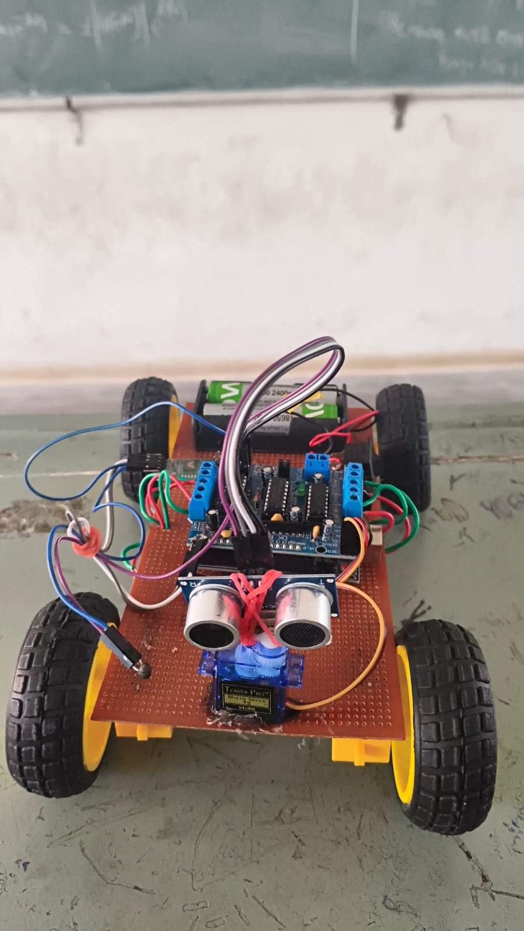

- Conclusion and FutureScope

The obstacle avoidance robot with voice and Bluetooth control features successfully demonstrates the integration of autonomous navigation and user-controlled operation in a single system. Built using the Arduino Uno, the robot efficiently processes inputs from the HC-SR04 to detect obstacles and avoid collisions without human intervention. At the same time, it allows manual control through a Bluetooth control app and hands-free operation via a voice control app.The project meets its primary objectives by providing reliable performance, smooth switching between control modes, and accurate response to commands. It highlights the effectiveness of combining sensor-based automation with wireless and voice technologies, making the system flexible, interactive, and easy to use. Overall, this project serves as a strong foundation for developing intelligent robotic systems and demonstrates practical applications of embedded systems in real-world scenarios.The project can be further enhanced in several ways to improve its performance and expand its applications. Advanced sensors such as infrared or LiDAR can be integrated to increase accuracy and enable better obstacle detection in complex environments. The system can also be upgraded by replacing the Arduino Uno with more powerful controllers to support real-time data processing and additional features.

- References
- Attar, A., Ansari, A., Desai, A., Khan, S., & Sonawale, D. A. (1987, August). Line follower and obstacle avoidance bot using Arduino. International
- Journal of Advanced Computational Engineering and Networking, 2, 740– 741.
- Adhvaryu, A. D., et al. (2005Kinsky, P., & Zhou, Q. Obstacle avoidance robot. Polytechnic Institute..
- Tabassum, F., Lopa, S., Tarek, M. M., & Ferdosi, B. J. Obstacle avoidance car. Gl, April). Obstacle-avoiding robot with IR and PIR motion sensors. IOP Conference Series: Materials Science and Engineering, A247, 529–551.
- Vaghela, A., Patel, J., & Vaghela, S. (2005). Obstacle avoidance robotic vehicle using ultrasonic sensor, Android and Bluetooth for obstacle detection.
- International Research Journal of Engineering and Technology (IRJET), A247, 29–32
- obal Journal of Researches in Engineering: H Robotics & Nano-Tech.
- Shree, B. S. R., & Kollam, M. (2011). Zigbee wireless sensor network for better interactive industrial automation. In Proceedings of IEEE ICoAC 2011
- Chang, M. (2004). Descriptive geometry and engineering graphics (3rd ed.).
- Huazhong University of Science and Technology Press.
- Zhou, S. (2005). Fundamentals for mechanical manufacturing process. Huazhong University of Science and Technology Press.
- Ni, J., Li, G., & Qian, Q. (2006). Mechanical of materials. Huazhong University of Technology Press.
- Simha, P. S. N. (2016, May). Design and development of real time self-navigation robot for agricultural activities. International Journal of Advanced Research in Electrical, Electronics and Instrumentation Engineering, 5(5).

